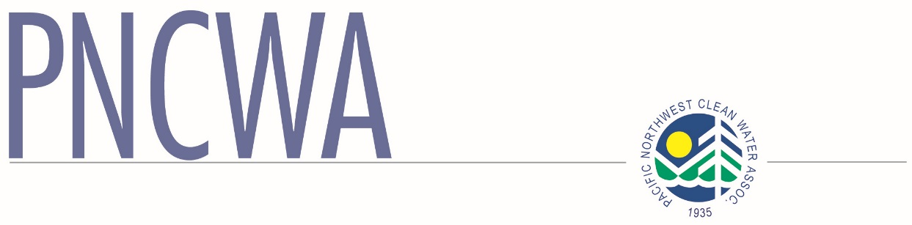

PO Box 100

Hansen, ID 83334

www.pncwa.org

208.455.8381 phone/fax

Pacific Northwest Clean Water Association

PNCWA 2015 Scholarship Application

Name:       Phone:

Street Address:

City:       State:       Zip Code:

E-Mail:       Date of Birth:

Female  I am a PNCWA member. *(If not a member, but have an immediate family member that is a member fill in information below. Membership or having a Sponsoring Member is not required.)*

Male  Sponsoring Member:       Relationship:

I am a U.S. Citizen

**School Information**

I currently attend:   High School  2-year College  4-year College or University

Name of School:

Anticipated Graduation Date:       Grade Point Average:

SAT / ACT Score:       Class Rank:       out of

Honors or Awards Received:

Extracurricular Activities:

Hobbies:

Education Goals:

Career Goals:

Current Employer, if any:       Hours per week:

High School Students: specify College or university you will attend, or if still unknown, schools applied to:

Intended Major:

Current College Students: Major or Intended Major:

**Other Information**

List volunteer community service and other extracurricular activities you have participated in within the last five years. (This could include professional or scholastic associations’ community outreach such as tutoring).

1.

2.

3.

4.

Are you currently certified or licensed in a field relevant to the water works industry?

If so, complete the following: State Level or License Type Number, Year Earned

Are you the recipient of any other scholarships for the 2015–2016 year?

Yes

No

If yes, please list from whom and amounts:

**Essays**

Please prepare one essay that provides responses to each of the items described below. Your essay should be approximately 800-1,000 words in length.

1. Career Objectives: Describe your interest in the water environment and how this interest influences your career goals and objectives. Discuss your plans to pursue a career in the water/wastewater/environmental profession.
2. Environmental Interest: Explain how this scholarship and your educational choices will help you contribute to the water environment field.

For prior award recipients, please prepare a separate Award Renewal essay (see Selection Criteria).

**Certification and Release Authorization**

The following information must be completed for the applicant to be considered for scholarship awards.

*I certify this information is true, complete and accurate. I also authorize the release of this information to confirm and/or verify this application.*

Student’s Signature: ______________________________________ Date:

Parent/Guardian Signature: _________________________________ Date:

(If under 18 years of age)

**CHECKLIST:**

For a submission to be considered for an award, it must be complete. The following items are all required:

1. Completed and Signed Application (typed or printed neatly)
2. Official Transcript (copies not accepted)
3. Required Essay (or Essays if you are a prior PNCWA award recipient)
4. Verification Letter (See Instructions for Applicants)
5. Reference/Recommendation Letters—a minimum of two letters of recommendation: one must be from a teacher or professor, the other must be from someone not related to the applicant.

**Applications must be postmarked or faxed no later than May 22, 2015.**

Pacific Northwest Clean Water Association, PO Box 100, Hansen ID 83334

Phone and Fax: 208 455-8381 [www.pncwa.org](http://www.pncwa.org)